School in a Different Way
My name is ________________ and I go to ________________________ School.
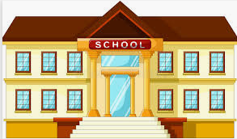

The government (people who make decisions and run our country) are putting things in place to help look after everyone. This is because there are a lot of things happening in the world at the minute and some people are getting ill.

One of the things that they are doing means that school may be different. My school might be closed or I might do school work at home or at my child minder’s house – the adults at home will let me know how school will be different for me.
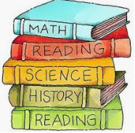

Even though I may not be in my school building, I will have school work to complete.
This will be set for me by my teachers. Some of the types of work might include:

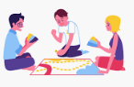
- Worksheets to complete
- Games to play
- Booklets to complete
- Tasks to complete on the computer
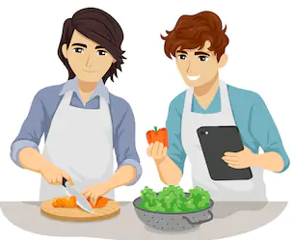
- Tasks to complete at home
- Books to read
- Exercises to do
- Projects to complete
- Other work set by my teacher

My teachers will let me know what the work is and where to find it. It might be sent home in a big pack or I might have to check on the computer / tablet / IPad / App / phone to find out what it is.
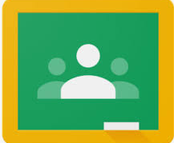

My teachers may also let those at home know what the work is and they will tell me what my tasks to complete are.

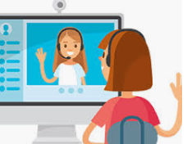
Sometimes I might have to go onto the computer to find out about my tasks and I might even have to take pictures of my tasks / video my tasks / send my work back into school / upload my work to the computer. I do not need to worry about this – someone at home will be able to help me with it and to work out what needs to be done.

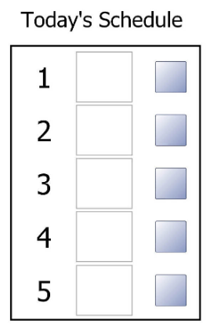
I will still have a schedule / timetable – this will help me to know what I am going to be doing each day. This may not be the same as it is in school, but the adults at home will help me with this. The adults at home will tell me what I will be doing each day.
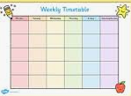

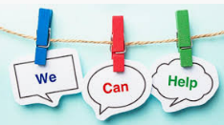
If I need help I should ask an adult – they are all here to help me.

My teachers and school will be in contact with the adults at home and will let them know what is happening. The adults will then let me know what is happening.
It will be good fun to try school in a different way
and I can learn lots of new things.

