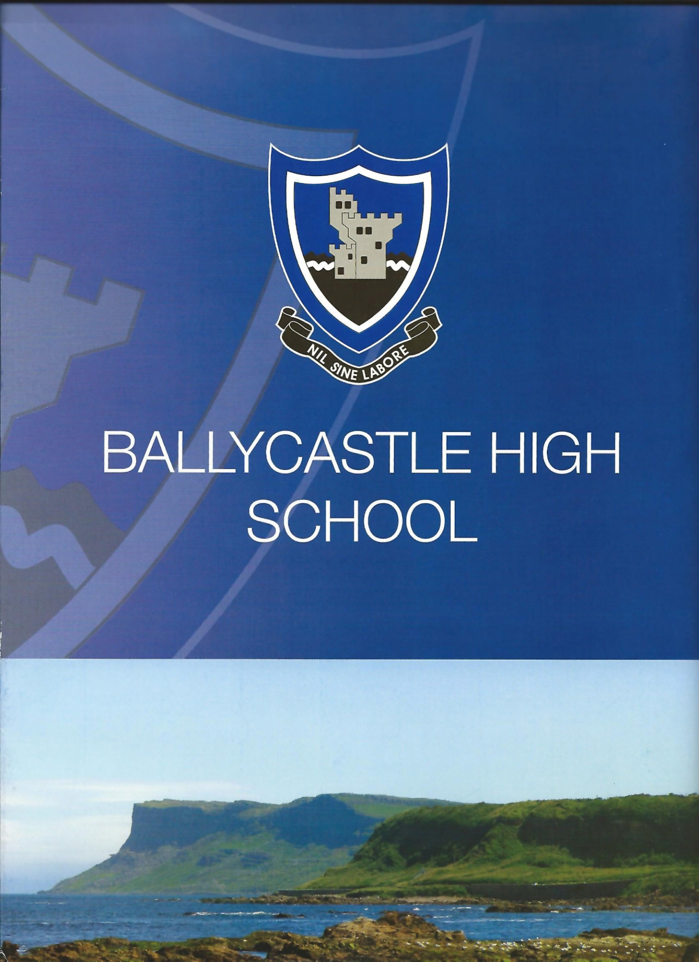
Sixth Form Prospectus 2022
CONTENTS
 |  | Page
Welcome |  | 1
Why choose Ballycastle High School? |  | 2
Academic Life |  | 3
Pupil Support |  | 8
Welcoming New Pupils |  | 9
Careers Provision |  | 10
Uniform |  | 12
Shared Education |  | 13
Admissions Criteria |  | 14
EMA |  | 15
The Role of Parents/Carers |  | 15
Access to Information |  | 15

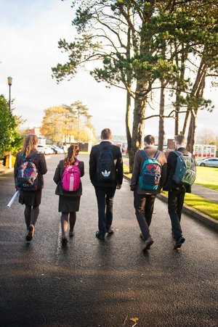
WELCOME

Welcome to the Sixth Form at Ballycastle High School. This document is intended to provide a flavour of the vibrancy and diversity that makes our school such a unique and exciting place to study.

We are a pupil centred school in that we believe academic success requires both the expert teacher guidance you would associate with demanding Advanced Level courses, and a large emphasis on emotional health and well-being. We believe that to be truly successful at Advanced Level it is necessary to cater for all pupil needs, including those that exist outside of the classroom. We work hard to get to know our pupils, to develop positive and honest relationships based on mutual trust and respect.

A very high proportion of our leaving pupils apply to university, most gaining access to their first choice institutions and courses. When our pupils leave at age 18 they are mature, thoughtful and have an appreciation of how to be caring members of their community.

The Sixth Form at Ballycastle High School is a happy, thriving environment and a place of real learning. Your sixth form years are as exciting as they are important. They provide key foundations for your future career. The decisions you make over courses are therefore vital and we hope that the information contained in the prospectus will answer some of your questions and help inform your decision making.

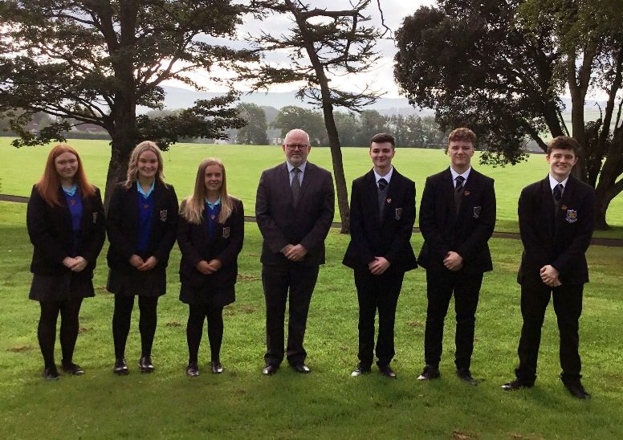
We have high expectations of our pupils and at Post-16 - we look for those who have a positive work ethic, those who want to achieve and who have a proven attendance and behaviour record.

If you have any questions or would like more information, please feel free to contact the school office. We look forward to welcoming you.

Why Choose Ballycastle High School?

If you are accepted into our Sixth Form you are entering into a partnership. We can offer you an enjoyable, interesting and challenging menu of subjects in both academic and vocational qualifications and we will help direct you towards enhancement activities, clubs and leadership opportunities best suited to your interests, and career aspirations. But, be prepared to be challenged because sixth form is about expanding your horizons and experience, not sitting in your comfort zone!

What do we expect of you?

Your commitment to Ballycastle High School means you will:
What can you expect?

Our commitment to you means we will:

• Work hard and collaborate with your teachers;
• Take responsibility for your own learning;
• Contribute to school and the wider community, serving as a positive role model to younger students;
• Attend school every day and wear the uniform correctly;
• Develop as a person taking advantage of the leadership opportunities offered.
• Provide you with a course of study to match your ability and aspirations;
• Provide you with a high quality teaching and learning environment;
• Track and mentor you on your qualifications pathway;
• Provide a range of extra-curricular, enhancement and leadership opportunities;
• Provide a caring and friendly sixth form community.

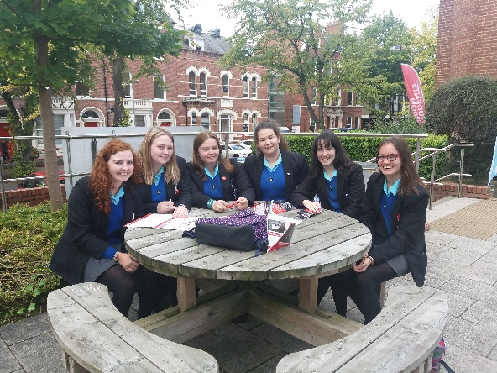
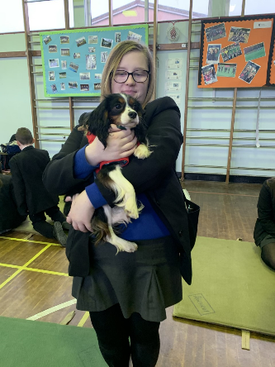

Academic Life:
Which subjects will you choose?

The biggest difference between Year 12 and Sixth Form is independence. As a sixth form pupil you are expected to be self-motivated and self-directed. Your approach must be professional and your studies should be your ultimate priority’ if you are to achieve your best. This independence extends to all aspects of your sixth form experience, from your academic subjects to your extra-curricular activities.

Post-16 study is very different from GCSE study and it is important that you make the right choice before you start. There are some things you can do to help you make the correct decisions.

Making the decision – positive action checklist

- Read the information in this prospectus thoroughly.
- Talk to your Head of Year and your subject teachers.
- Discuss your thoughts and feelings with your parents and, if you have them, older siblings.
- Arrange to meet with sixth form pupils who study the subjects in which you are interested in.
- Use the Careers Department and computer facilities in support of your personal research.
- Think ahead, two years from now. Where do you want to be?

FAQs

- What is the difference between A-levels and BTEC/CTEC qualifications?

In general terms, A-levels are academic, and BTEC/CTEC courses are their vocational equivalent. This means that BTECs and CTECs are designed to reflect the knowledge and skills required in a particular area of employment, such as health care, information technology, business and so on.

Both qualifications will require you to complete coursework and external exams, but there tends to be a greater emphasis on coursework in BTEC/CTEC courses. Coursework tasks generally during post-16 study are much more time consuming and are completed to a much higher standard than at GCSE. It often requires you to do your own research, and you will be expected to spend your study periods completing your coursework.

- Which subjects should I choose?

Choose subjects that you like and are good at. Subjects at A-level are studied in much greater depth than at GCSE and there is a much greater emphasis on personal study. It is therefore important that you have a genuine interest in the subject, so that you will be motivated and find it easier to study. If you have a good record in a subject in year 12, it might be sensible to choose that subject in sixth form.

Choose subjects you will need for your career. It is important at this stage that you plan ahead and choose subjects that are needed for entry into university or college, or are needed for employment. Your post-16 study should be a means to an end and you will be far more motivated to succeed if you know what that end is!

So, before making your final choice you should find out what subjects are required for your chosen career (if you don’t know what this is yet, refer to question 3!) and in this way you will save time later and you will ensure that you can gain entry to your chosen course.

- What if I have no idea what career I want?

Choose subjects that keep your options open. Don’t limit your options to the extent that you can only choose from a very narrow range of subjects at further and higher education. This will require research and patience on your part, but it will be worth it when you begin looking at courses at university.

4. I don’t know where to start! Who can help?

Relax, lots of people are only too willing to assist you.

Firstly, talk to your subject teachers.
Your GCSE teacher will be able to advise you on the requirements for post-16. They will also be able to guide you on the suitability of a particular subject for you personally.

Secondly, talk to your careers teacher. They will have a good overview of the different types of courses and the relevant information from universities and colleges. You can use this information to help you choose what subjects to study.

Thirdly, talk to students already in the sixth form.
Go straight to those who know. Find out what the subjects you are interested in are like from the pupils’ perspective.

The internet is another great source of information. You can use this to check courses at individual universities, or check for advice on careers in specific areas, e.g. the environment. One useful site is: https://www.ucas.com/

Academic Life:
POST-16 CURRICULUM

The post-16 curriculum allows pupils to study:

Advanced Levels
These are level 3 courses in a range of subject areas that would be considered traditional school subjects. General A Levels are very knowledge-based and require a high level of competence in literacy and numeracy. They are assessed through a combination of coursework and formal exanimation.

Modules are taken in June of Year 13 (AS) (for most subjects) and Year 14 (A2). These qualifications are graded A* to E.

BTEC / CTEC Level 3
These are level 3 courses equivalent in value to A levels. We offer BTEC / CTEC qualifications in a range of subjects linked to vocational areas, such as Science, Sport and Travel and Tourism. In these courses students apply their knowledge and skills to tasks that are very relevant to a career in these areas of study. The tasks are a combination of theory and hands-on practical experience, which help students to develop a deeper understanding of issues linked to that area. Once again, a competent level of literacy and numeracy is required for success in these courses, as well as the ability to work independently and as a team. Final grades are in the format: D* (A* equivalent), D (grade A equivalent), M (grade C equivalent) and P (E grade equivalent).

All of the above courses carry UCAS accreditation and are recognised by universities within and beyond Northern Ireland as appropriate foundations for access to degree level courses.

GCSE Repeat Examinations (Maths or English)

In addition to the academic subjects, pupils are timetabled for:
Private Study
Careers
General Studies
Curriculum Enrichment (Activities)

Enrichment Programme
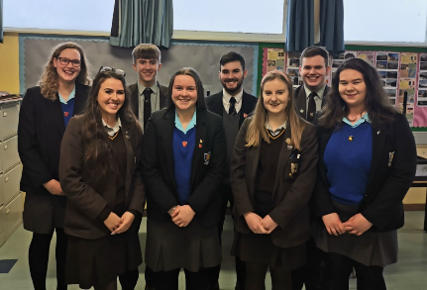
This is part of every pupil’s timetable, and it is an opportunity for students to develop new skills and interests. Each pupil will be expected to make full use of the time by participating in one or more of the following opportunities:
- Survival Cookery
- Games
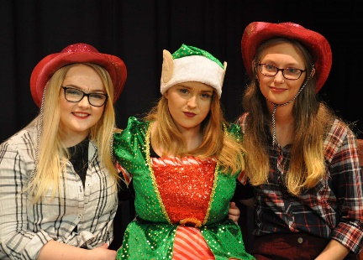
- Life Skills
- Volunteering
- Mentoring
- Sports’ Leadership Award
- Language for Pleasure

Pupils can also access the following opportunities outside of the
timetable:
- Peer Mentoring
- Charity Committee
- Young Enterprise (Mini Business)
- Senior Leadership Team
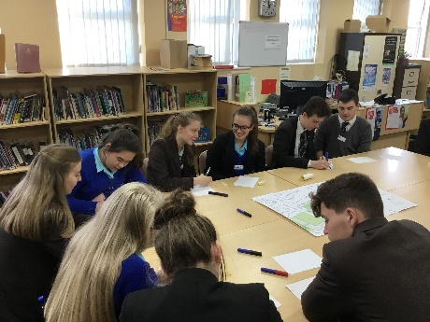
- Joint School Council
(with Cross & Passion College)
- School Council
- House Committee

Today, university admissions tutors and indeed employers are demanding more from our young people. It is our responsibility to provide opportunities to develop skills that will enhance your development without adding significantly to your already large workloads. We try to provide a range of opportunities that are challenging but rewarding, that require commitment but are fun and that ultimately make a difference to your educational experience and future aspirations.

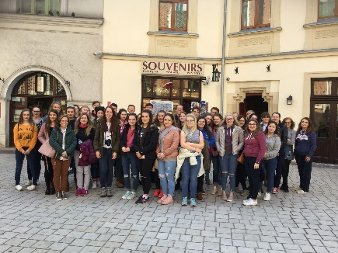
Our advice to pupils is: get involved!

PUPIL SUPPORT

The programme in the sixth form is designed to provide pupils with the academic and pastoral support they need. There are a number of different components:

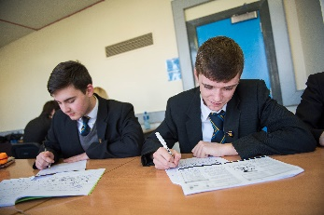
- The Head of Year
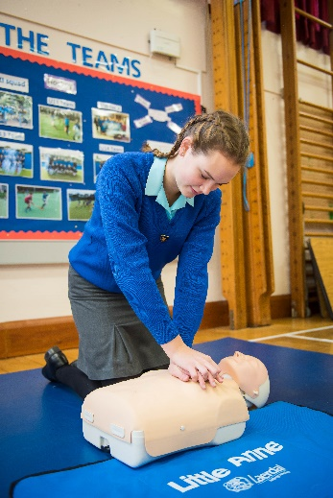
The Head of Year gets to personally know each of the students in the sixth form. Form Tutors refer pupils to the Head of Year and can provide additional support where necessary. The Head of Year organises the initial induction day for Year 13 students. Above all, in conjunction with the Form Tutor, the Head of Year is a sympathetic listener, there to offer support, advice and help in all matters.

- The Form Teacher
Their role is to ensure the day to day well-being of pupils and to give advice on how to manage schoolwork on top of the other demands placed upon them. Attendance is closely monitored as the school believes that Attendance + Attitude = Attainment. The role of the Form Tutor also extends to that of monitoring and encouraging punctuality to school.

- Study
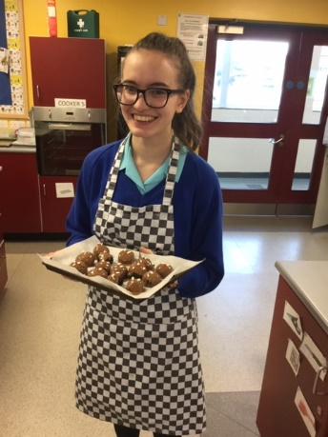
In addition to recently refurbished sixth form study facilities, there are also facilities that allow pupils to take a break: soft seating, kitchen facilities and access to a pool table and other recreational activities.

- General Studies Programme
The General Studies programme has been designed to provide each student with the skills and awareness they will need to progress through sixth form and into university or employment.
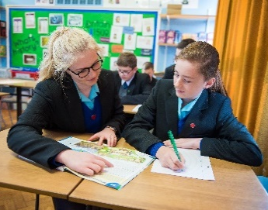
The programme includes motivation and study skills, preparation for work experience, UCAS applications and personal statements, first aid, finance and personal development.

WELCOMING NEW PUPILS
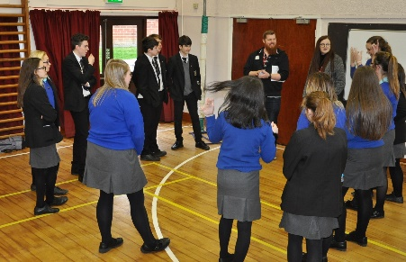
Ballycastle High School is particularly pleased to welcome new students. We appreciate that it is a difficult decision to change schools at age 16 and that the prospect of making new friends can seem daunting.

We have worked hard to try and make this transition as smooth as possible. Please be assured that we will do everything we can to try and ensure that you feel welcome and that the start of your new school career is focused on the most important issue – your personal success.

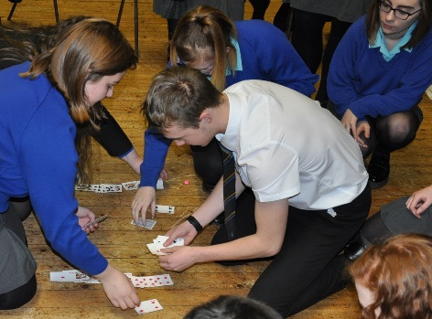
YEAR 13 INDUCTION

There are several parts to our induction process:

In School – Day 1
Pupils have the opportunity to:
- Settle in and make friends.
- Meet their Head of Year and Form Teacher.
- Take part in team-building games.
- Get introduced to post-16 study and what it entails.

Carrowmena – Day 2
Pupils travel to Carrowmena to take part in activities such as archery, laser tag, team-building games, etc. This allows relationships to develop between pupils and key staff, in a relaxed and informal setting.

Collaborative Induction – Day 3
A key part of sixth form in Ballycastle High School is the relationship and collaboration with Cross and Passion College. Pupils will have the opportunity to:
- Meet Year 13 pupils from Cross and Passion College.
- Meet key staff from Cross and Passion college.
- Have a tour of Cross and Passion college.

Subject Specific Induction
Subject teachers will:
- Ensure that you can access all of the rooms on your timetable.
- Provide you with an overview of the course.
- Spend time getting to know the class and developing relationships.
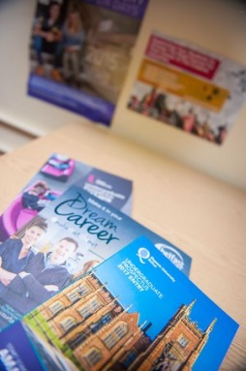
CAREERS PROVISION

Given the ever changing world of employment trends and the unpredictable nature of the economic climate, it is increasingly important to ensure that all young people are equipped with the skills to manage their learning pathways and associated transitions. This can best be achieved through a high quality CEIAG programme.

We endeavour to:-
- Provide a planned, progressive programme of CEIAG activities in line with statutory requirements, which meets the individual needs of our pupils.

- Provide pupils with opportunities and experience to develop the essential employability skills to become effective participants in the world of work.

- Provide access to comprehensive, clear, accurate and objective information about the full range of learning and vocational pathways accessible to all.

- Provide access to impartial advice and guidance commensurate with the individual abilities, interests and aspirations of pupils, in order for them to make well informed and realistic career decisions.

- Give opportunities for planned and appropriate work-related learning experiences to enhance pupils’ motivation and develop employability skills.

- Provide a structured careers education programme in Years 13 and 14 which supports pupils in establishing and following a personal career plan based on recognition of their strengths, weaknesses, interests and values.

- Provide pupils with the opportunities to research higher education, further education, training and employment opportunities available to them using a range of sources, role models, library, prospectus and ICT.

- Aid pupils in further decision making including parental involvement.

- Aid pupils in further development of job search skills e.g. interview skills, CV creation etc.

- Give students an understanding and use of further education and higher education application systems e.g. UCAS.

- Make pupils aware of student finance and money management.

Work Experience

All year 13 pupils participate in a week of work placement relevant to their chosen career.

Appropriate experiences of the world of work improve pupils’ self-awareness, increase motivation to learn, give relevance to their subject choices, and increase their knowledge and understanding of the requirements of a range of occupations.
Furthermore, universities have highlighted work experience as an area on which they will look favourably within applications. Clearly much importance is attached to work experience and so we have made it a mandatory aspect of our post-16 provision.

UNIFORM
A full uniform list, and local suppliers, can be found in our main school prospectus. The only additional item is the sixth form tie (boys only) which may only be purchased from the school office.

All pupils are expected to take pride in their appearance and all must attend the school in full, correct uniform.

We believe that wearing school uniform helps pupils to take pride in themselves and in their school. A school uniform also gives all pupils a sense of belonging.

A scheme for assistance in the purchase of school uniform, games and physical education clothing is operated by the Education Authority. Further details are available directly from the EA or the Principal will advise, if required.

The official Sixth Form school tie can be purchased only from the school office.

All school uniform and P.E. uniform will be supplied by:
S & T Moore, 28 Railway Road, Coleraine.
S & T Moore, Sperrin Business Park, Ballycastle Road, Coleraine.
R. H. Gault, Church Street, Ballymoney.

Sixth Form Boys’ Uniform:  - Black Blazer with school badge  - Black trousers  - White shirt  - Sixth Form School tie  - Grey Jumper (compulsory)  - Black socks  - Black shoes | Sixth Form Girls’ Uniform:  - Black Blazer with school badge  - Grey knee length skirt (with four 6 inch pleats) or grey school trousers  - White shirt  - Sixth Form School tie  - Royal blue V-neck jumper  - Plain black tights  - Black shoes (low heel)

Optional
Black school outdoor coat with fleece lining and school badge (to be worn over blazer)
School Scarf (no other scarf may be worn)
Both items are available from school suppliers

For practical and safety reasons, jewellery should not be worn, with the exception of a plain stud in the lower ear lobe.

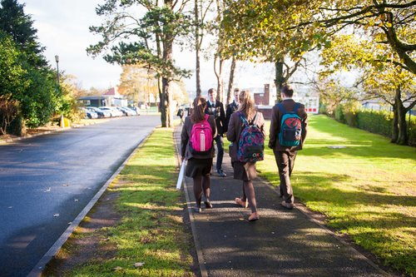
SHARED EDUCATION
Pupils in Years 11 to 14 enjoy the benefits of a very close collaborative arrangement with Cross and Passion College, which enables both schools to offer a greater choice and a broad, balanced curriculum. This arrangement enables all of our young people to be challenged, and offers them opportunities to study subjects from a wide range of specialisms.

The Purpose of Shared Education
- To enhance educational opportunities for all young people in post primary education in North Antrim – enhancing choice – promoting quality.
- To improve outcomes for young people at Key Stages 4 and 5.
- To make the best use of educational resources available.
- To promote and nurture mutual respect and understanding, as well as community cohesion.
- To provide the local and wider community with young people who have the knowledge, skills and attitudes to make valuable contributions to the economic and community life within the area.

Key Facts
- Each school in the partnership retains its own identity and ethos.
- The commitment to sharing can be traced back as far as the 1960s, when pupils from Ballycastle High attended Latin lessons in Cross and Passion.
- The partnership is now well established and is deeply embedded in the life of both schools.
- In excess of 300 pupils from both schools share lessons on a day to day basis.
- The schools share 20% of the curriculum at Key Stage 4 – pupils still have the option to attend classes only in their own school.
- Pupils from both schools have a joint student council which meets regularly and represents the voice of pupils in making decisions about the partnership.
- Planning is underway for a state-of-the-art shared campus, consisting of two new schools and a shared facility.

POST-16 ADMISSION CRITERIA

1. The educational/vocational needs of the pupil seeking entry to post GCSE provision will be the fundamental consideration in the process of assessing suitability to enrol subject to the following:
- a pupil will be considered for enrolment provided the school does not exceed its enrolment number as determined by DENI;
- a pupil may be accepted into the school provided this would not prejudice the efficient
  - use of the school’s resources,
  - provision of education in the school;
- academic achievement - the applicant should have obtained a minimum of four GCSEs at A* - C and more normally a minimum points score of 36, where grades A, B and C are worth 10, 8 and 6 respectively;
- level of industry must demonstrate a potential to benefit from a post GCSE course of study – this will be assessed by reference to available tracking data, Key Stage 4 reports, attendance records, subjects studied and relevance to post-16 courses;
- approach to schoolwork, peers and staff - this will be assessed by reference to school records.

2. A pupil who intends to take a combination of A level and/or other courses will be required to have commensurate levels of attainment that demonstrate their potential to cope successfully with the proposed course.

3. A pupil proposing to transfer from another school would be expected to meet the above criteria.

All applications for admission to the school should be made on EA form AP1 and submitted to the school office.

In the Event of Over-Subscription
Preference will be given to those:
(1) Who have a sibling or former family relationship with the school.
(2) To those living in closest proximity to the school.
(3) Children resident in N. Ireland at the time of their proposed admission will be selected before any child not so resident.
Education Maintenance Allowance (EMA)
Sixth Form pupils may qualify for the Education Maintenance Allowance. Bonus payments are available twice yearly and will be achieved if pupils fulfil the following criteria:
- Acceptable behaviour in the classroom and within the school environment.
- Coursework and homework deadlines met.
- Effort applied to learning and contributions to classwork.
- Punctuality to school.

Further details and application packs will be available from the school office in August.

The Role of Parent/Carers
Ballycastle High School recognises the valuable role of parent/carers and regard education as a three-way process; between the school, the pupil and the parent/carers. Frequent contact is made to parent/carers regarding the progress of the pupil. This is both through formal means e.g. report, and informal, telephone calls from the teacher, Form Tutor or Head of Year. We encourage and value communication with parents/carers and all sixth form staff are always available to talk to parents/carers regarding their son/daughter.

Access to information
All school policies are available on the school website: www.ballycastlehigh.org.uk

Alternatively, hard copies of relevant school policies are available on request from the school office.

Our full school prospectus is also available on our website.

